**Opioid Resource Team (ORT)**

**Workflow last update: 8/22/2019**

***Pharm Tech*** *(core of the Opioid Resource Team)*

***Pain Specialist*** *(used whenever a utox is reviewed, and Cc’d on correspondence)*

***ORT MD***

***Clinic Director MD***

***RNs***

***Flow Managers***

The team lead is *** (email), and they can be reached by email for any questions. Additionally, *** (email) is providing research support and can help answer questions

--------------------------------------------------------

All workflows require local modification and iteration. We recommend using PDSA cycles to help maximize learning from these modifications. This [template](https://www.ahrq.gov/sites/default/files/wysiwyg/evidencenow/tools-and-materials/pdsa-form.pdf) has been helpful in planning and tracking our PDSA cycles.

------------------------------------------------------

Two patient stories

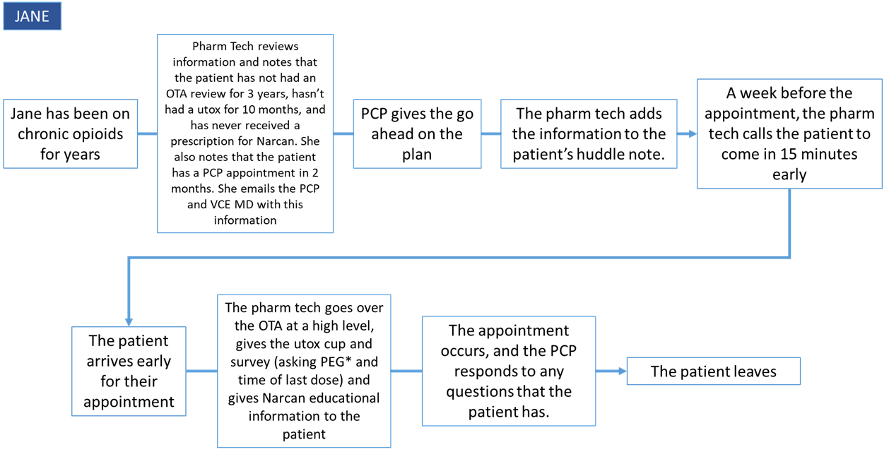

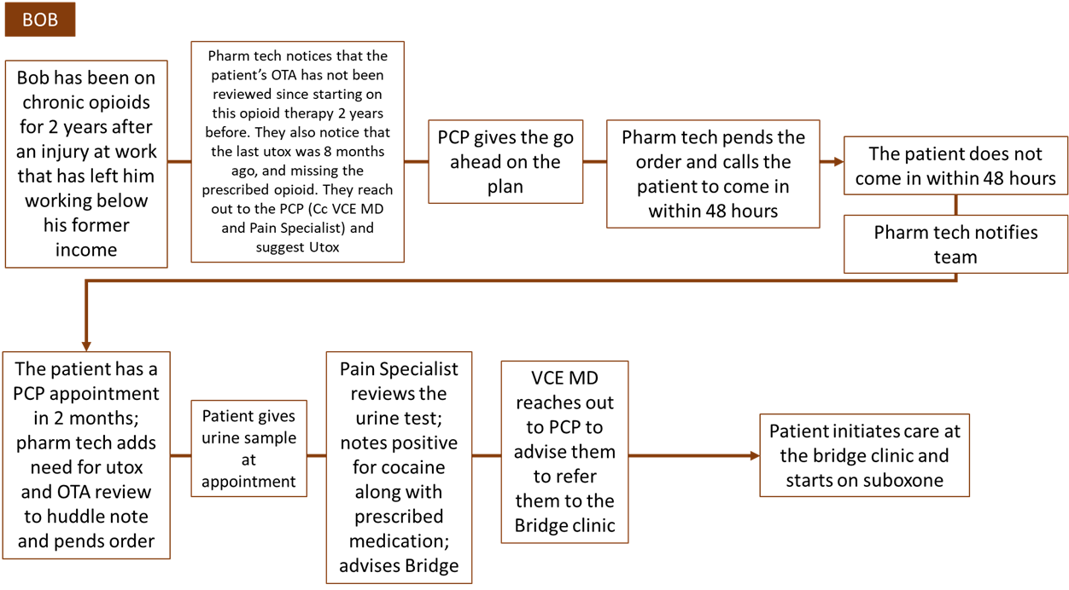

-------------------------------------------------------

**Pharmacy Tech**

Identify PCP and prescriber, determine whether adherent to protocol:

* 1. OTA on file last year
  2. Narcan Rx
  3. Non-aberrant Utox within 1 year
  4. Urine tox frequency
  5. Date of next utox
  6. Next PCP appt

**If:**

*Everything up to date:*

* Take no clinical action, **Pharm Tech** notes when patient needs to be re-reviewed

*Aberrant last utox:*

* Check to see what had been done in reaction?
* **ORT MD** to email prescriber and offer clinical resource options (e.g. Bridge), another utox, PCP appt, invite them to a Pain Board?
  + If they don’t respond to email/take action then resend
  + Track over time and update Bonnie after we have more information

*Missing one item*

* If no Narcan Rx
  + **ORT MD** to email Prescriber to discuss options
  + **ORT MD** to write Rx or call them if necessary
* If no OTA
  + **Pharm Tech** to reach out to Practice Assistant to schedule PCP appointment
    1. Goal timeline: 3 months max
    2. If the appt is scheduled, VCE Pharm Tech add this to the huddle note
    3. If no PCP appt available, have them see Michele
  + **ORT MD** to email Prescriber with info about need to sign OTA
* If no Utox
  + **ORT MD** to email the prescriber to write the order, if no response **Pharm Tech** pend
  + **(Pharmacy Tech)** to call patient and ask them to come in for a test within 48 hours (at lab or PJC)
    1. Get utox
       1. **Pain Specialist** and **ORT MD** review and send email advising clinician
    2. Don’t get utox - **(Pharmacy Tech)** follows up with a phone call to patient; reschedules via a note in the huddle of the next appointment. PCP alerted. When utox is collected, marked as “low confidence” test (not random)

*Missing two items:*

*\*If missing two or more items,* ***Pharm Tech*** *calls the patient and asks them to come in early to meet with the patient and go over information (e.g., introduce OTA, give utox kit, give narcan educational pamphlet)*

* If no Narcan Rx and no Utox,
  + Follow steps for “no Narcan Rx” and “no utox” in section above
* If no Narcan Rx and no OTA,
  + Follow “no OTA” above, with additional note from **ORT MD** re: Narcan prescription
  + If no Narcan Rx after appt (checked by **(Pharmacy Tech)**), **ORT MD** to write Rx
* If no OTA and no Utox
  + Follow “no OTA” and “no utox” above (if they consent that’s great), and **(Pharmacy Tech)** to write in huddle note the need for a utox at next PCP appointment

*Missing all three items:*

* Follow “no OTA” above, and **(Pharmacy Tech)** to write in huddle note the need for a utox at next PCP appointment, and additional note from **ORT MD** re: Narcan prescription

**Phone calls (Utox) - 1 month, 3 months, 1 time per year (high, moderate, low risk)**

* Registry would highlight them for a call for Pharm Tech
* Too busy to get there for randomized, find the time for utox
* Say they’ll come and they don’t; call and ask why they couldn’t make it and see above

Add in tx note put in whether the patient has difficult getting in (RIDE, etc.); communicate that there’s randomization

**Utox kit:** (Prepared by Pharm Tech)

* Brown bag
* Urine cup
* Print the label w/utox cup - date their expected date of arrival

**Utox test at the lab or in clinic:**

* Two workflows (described elsewhere):
  + Ask them to go to the lab nearest them (could be any affiliated lab)
  + Do urine test at the clinic (facilitated LPNs)